Metaphysics - Small Group Community of Inquiry Preparation
Metaphysics is the study of the nature of existence and reality. It is a broad and complex area of philosophy. Science, especially in recent history, has helped us to explain concepts relevant to reality and existence. However, there are many questions that are not so easily explained which are often a focus of metaphysical study.

To prepare us for a discussion about reality and existence, complete the following tasks.

INSTRUCTIONS:

- Find an image (photo, painting or sculpture) with an alternate perception of reality.
- Jot down notes (ready to share in a small group) on the following:
  - What type of reality is depicted in your picture?
  - What potential ideas does this image raise about reality? Note down any philosophical questions that could be / are raised when examining this image.

Examples of the types of image / ideas that could be found and analysed:

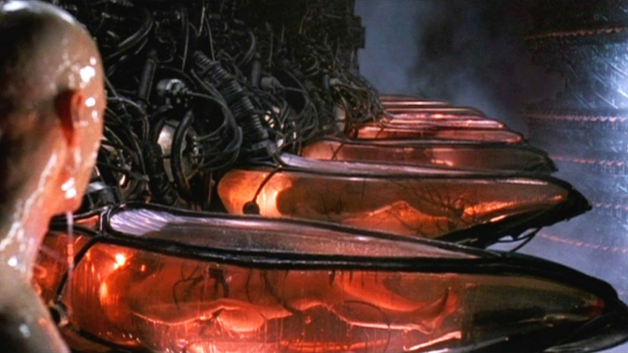
IMAGE A (from The Matrix)

Example analysis using IMAGE A:

What type of reality is depicted in your picture?

This image depicts the main character, Neo, waking up in the ‘real world’. This is different to the simulated reality (the Matrix) that Neo had been living in previously.

This form of reality shows humans in liquid-filled pods, plugged into a machine/system that harvests their bioelectric power. Not many people are aware of this reality, as their minds are being manipulated to think that they are in a ‘normal’ world.

What potential ideas does this image raise about reality? Note down any philosophical questions that could be / are raised when examining this image.

Are we living in a simulation?
Can human senses be trusted?
Are we being manipulated into having a false sense of reality?
How can you tell the difference between a dream and reality?

